**Jira Fundamentals and working on Scrum and Kanban boards with Backlog and Board views**

**Jira** is a project management and issue tracking tool widely used in Agile teams.

It helps teams:

* Plan work
* Track progress
* Manage bugs and tasks
* Collaborate efficiently

Jira is commonly used by:

* Development teams
* QA teams
* Project managers

**Team-managed and Company-managed Projects**

Jira supports two types of project configurations.

**Team-managed Projects**

* Managed directly by the team
* Simple and flexible setup
* Limited customization
* Best for small or independent teams

**Company-managed Projects**

* Managed by Jira administrators
* Highly configurable workflows and fields
* Shared schemes across projects
* Best for large organizations

Understanding both helps in adapting to different project environments.

**Issue Types in Jira**

**Issue Types** define the kind of work being tracked.

Common issue types include:

**Epic**

* Large body of work
* Contains multiple stories or tasks
* Spans multiple sprints

**Story**

* User-focused requirement
* Describes functionality from the end-user perspective

**Task**

* Technical or operational work
* Not always user-facing

**Bug**

* Represents a defect or error in the system
* Usually reported by QA

**Subtask**

* Smaller unit of work under a story or task
* Helps in better tracking and breakdown

**Creating, Updating, Assigning, and Tracking Issues**

Jira allows complete lifecycle management of issues.

Users can:

* Create issues with required details
* Update fields like status, priority, and description
* Assign issues to team members
* Track progress through status changes

This ensures visibility and accountability throughout the workflow.

**Issue Hierarchy**

**Issue Hierarchy** defines how issues are related.

Typical hierarchy:

* Epic
  + Story / Task
    - Subtask

Hierarchy helps in:

* Organizing work
* Tracking large features
* Understanding progress at different levels

**Scrum and Kanban Boards**

Jira supports Agile methodologies through boards.

**Scrum Boards**

* Used for sprint-based work
* Includes backlog and sprint views
* Suitable for planned iterations

**Kanban Boards**

* Used for continuous delivery
* Focus on workflow and limiting work in progress
* No fixed sprints

**Backlog and Board Views**

**Backlog View**

* Displays all upcoming issues
* Used for planning and prioritization
* Available in Scrum projects

**Board View**

* Visual representation of work status
* Shows issues across workflow columns
* Used daily by teams to track progress

**Hands-on Practice:**

**JIRA PRACTICE ON SCRUM PROJECT (Team managed):**

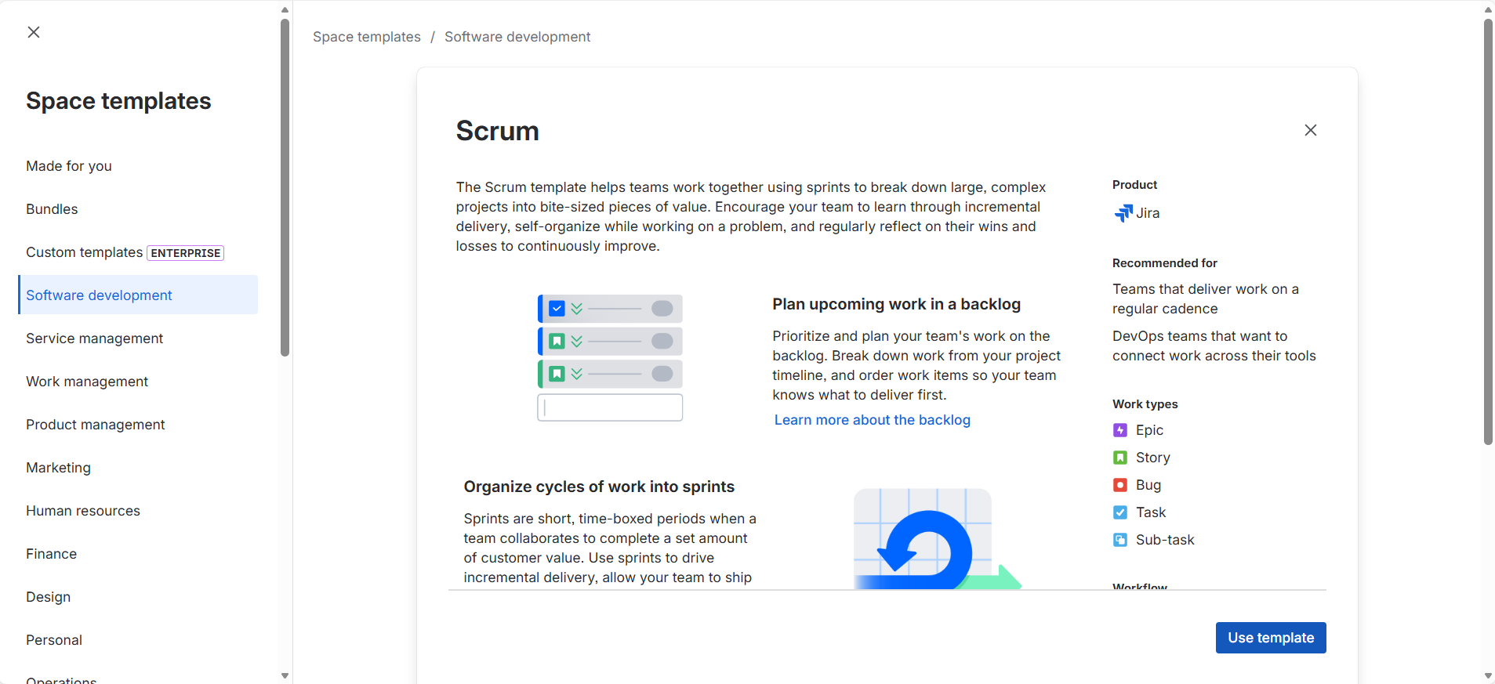

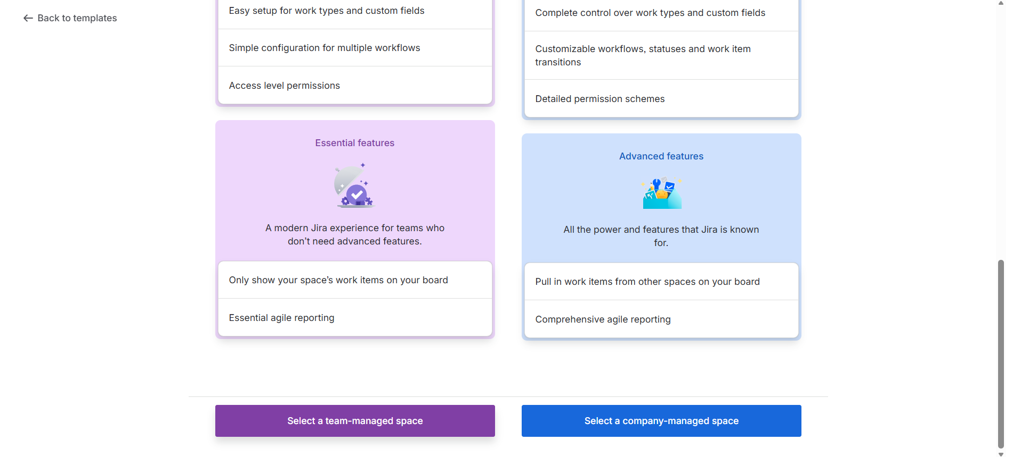

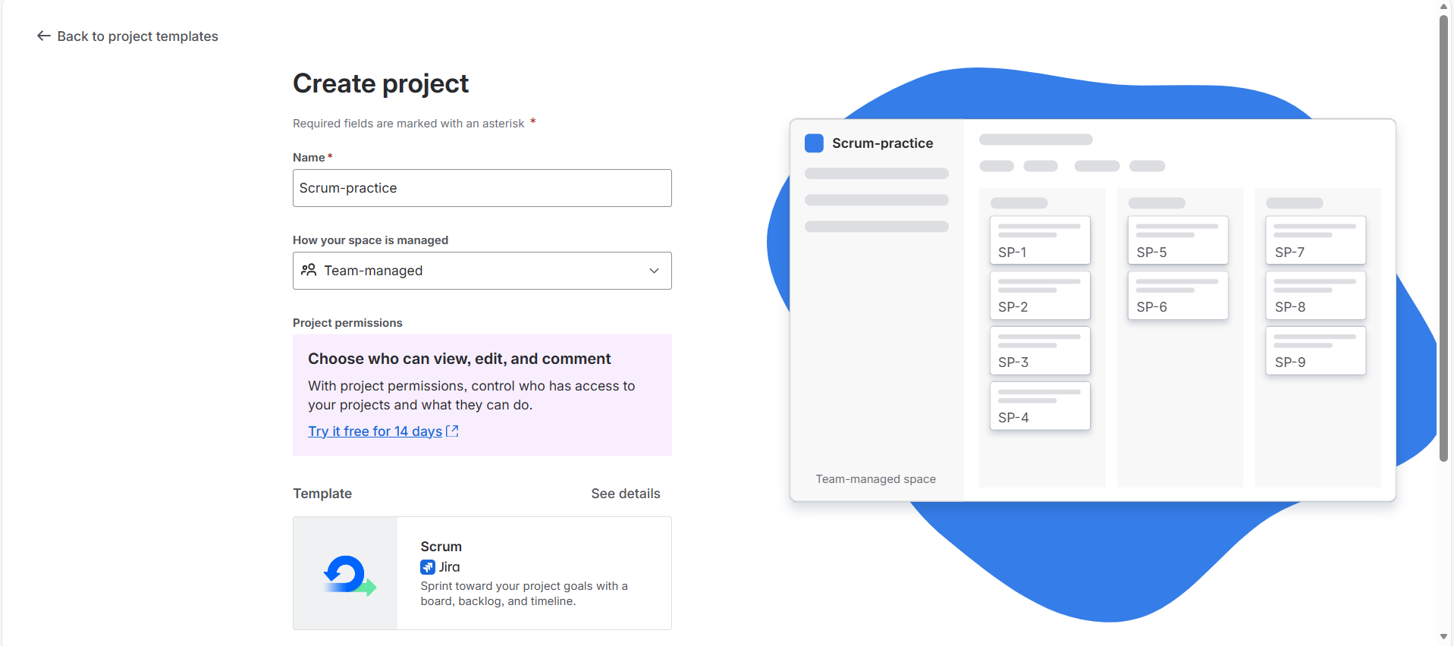

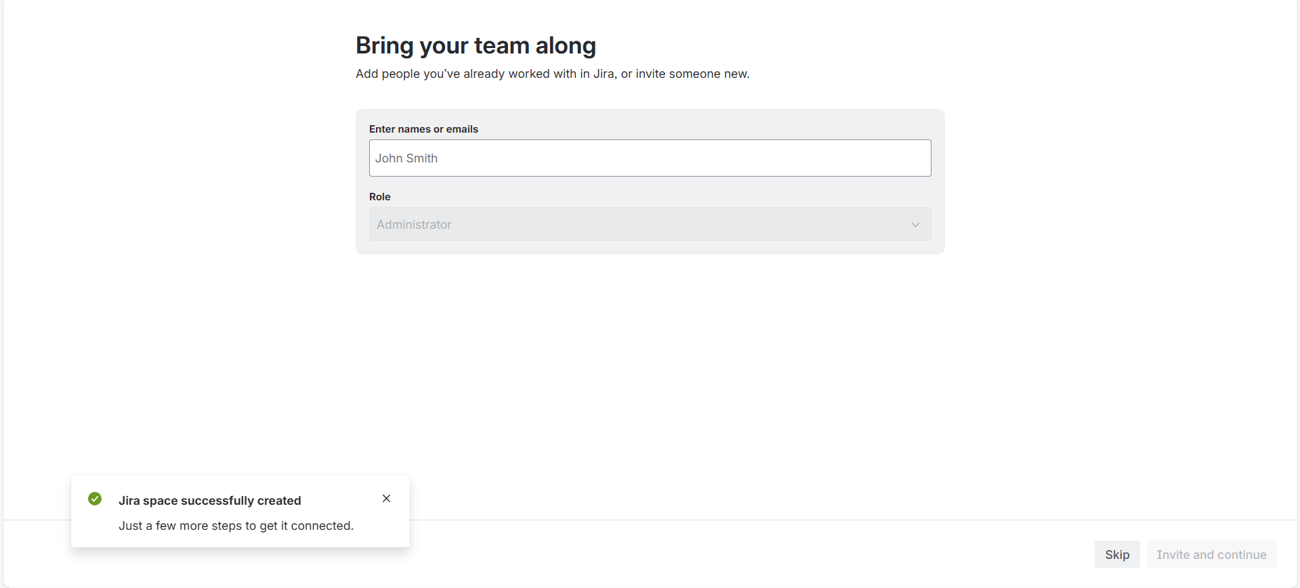

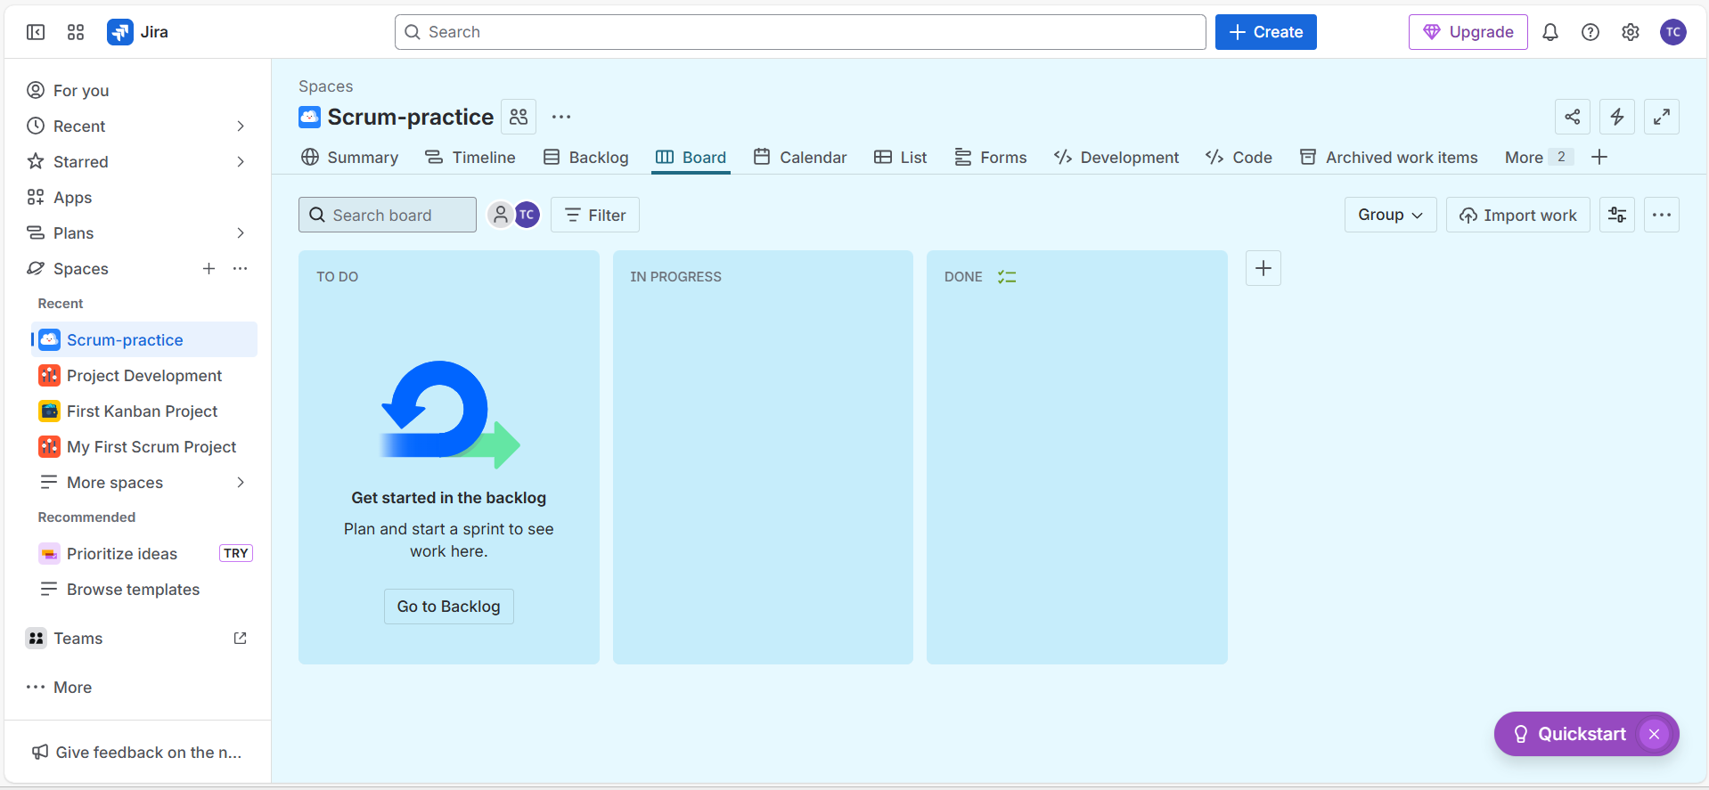

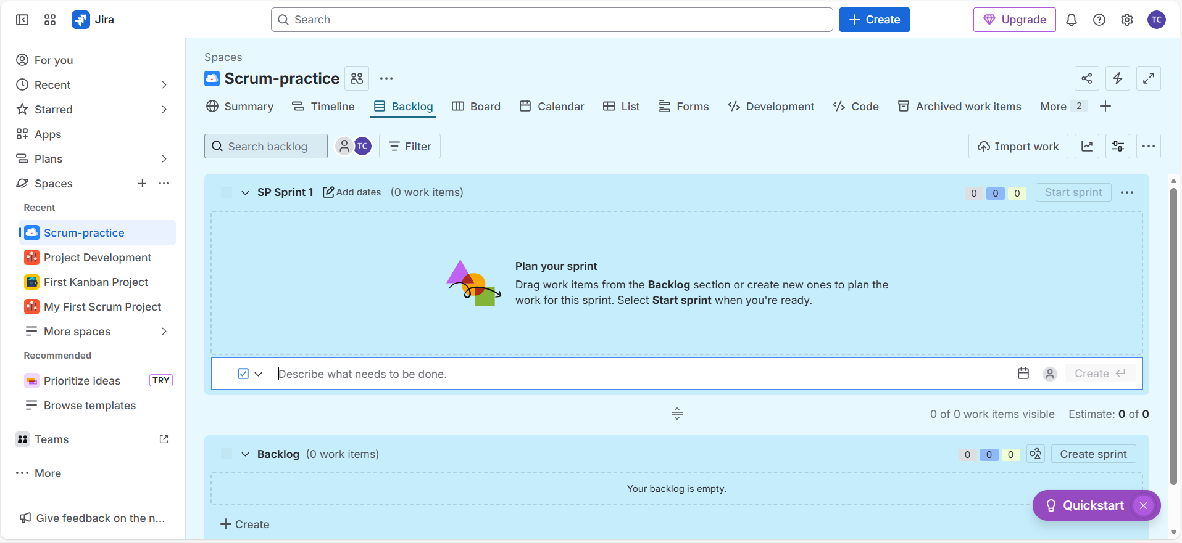

Create Epic via the + Create button at the top :

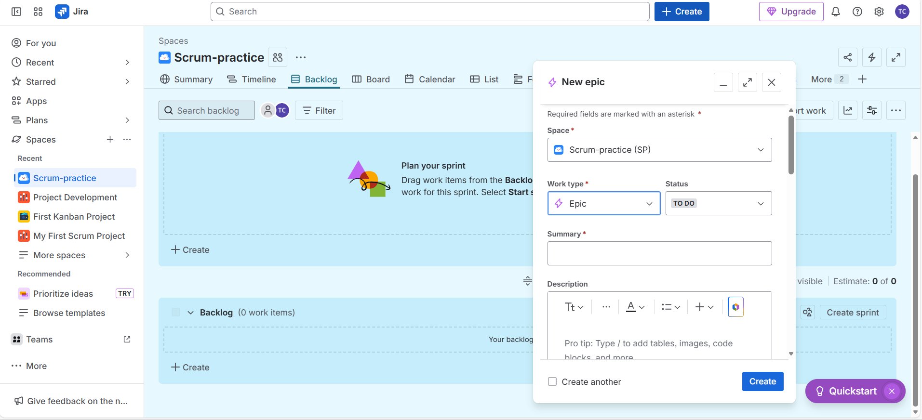

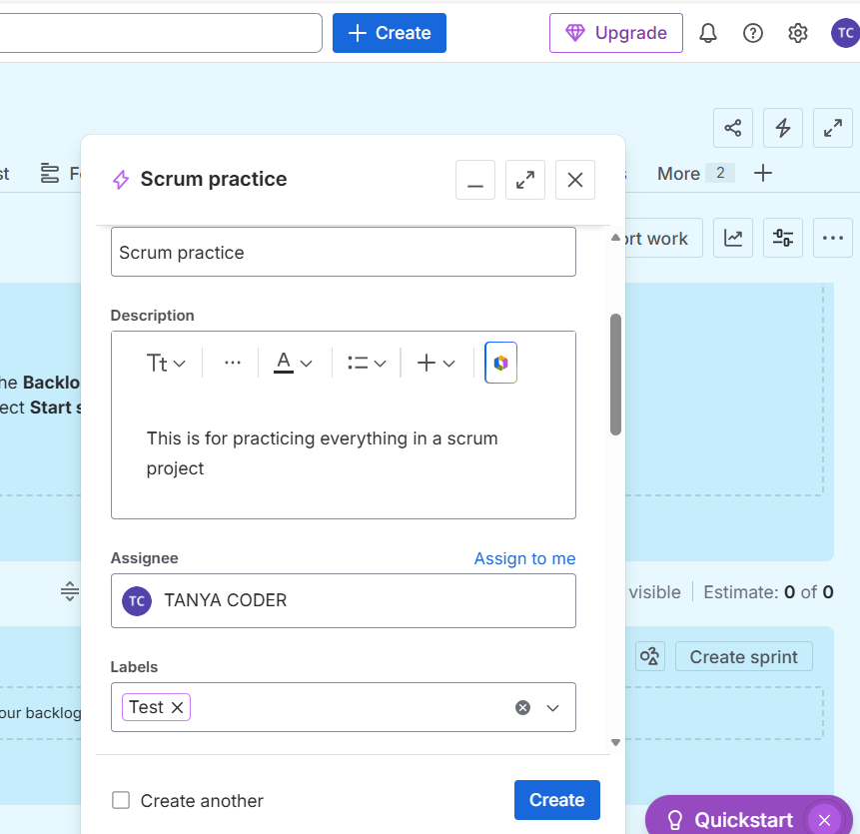

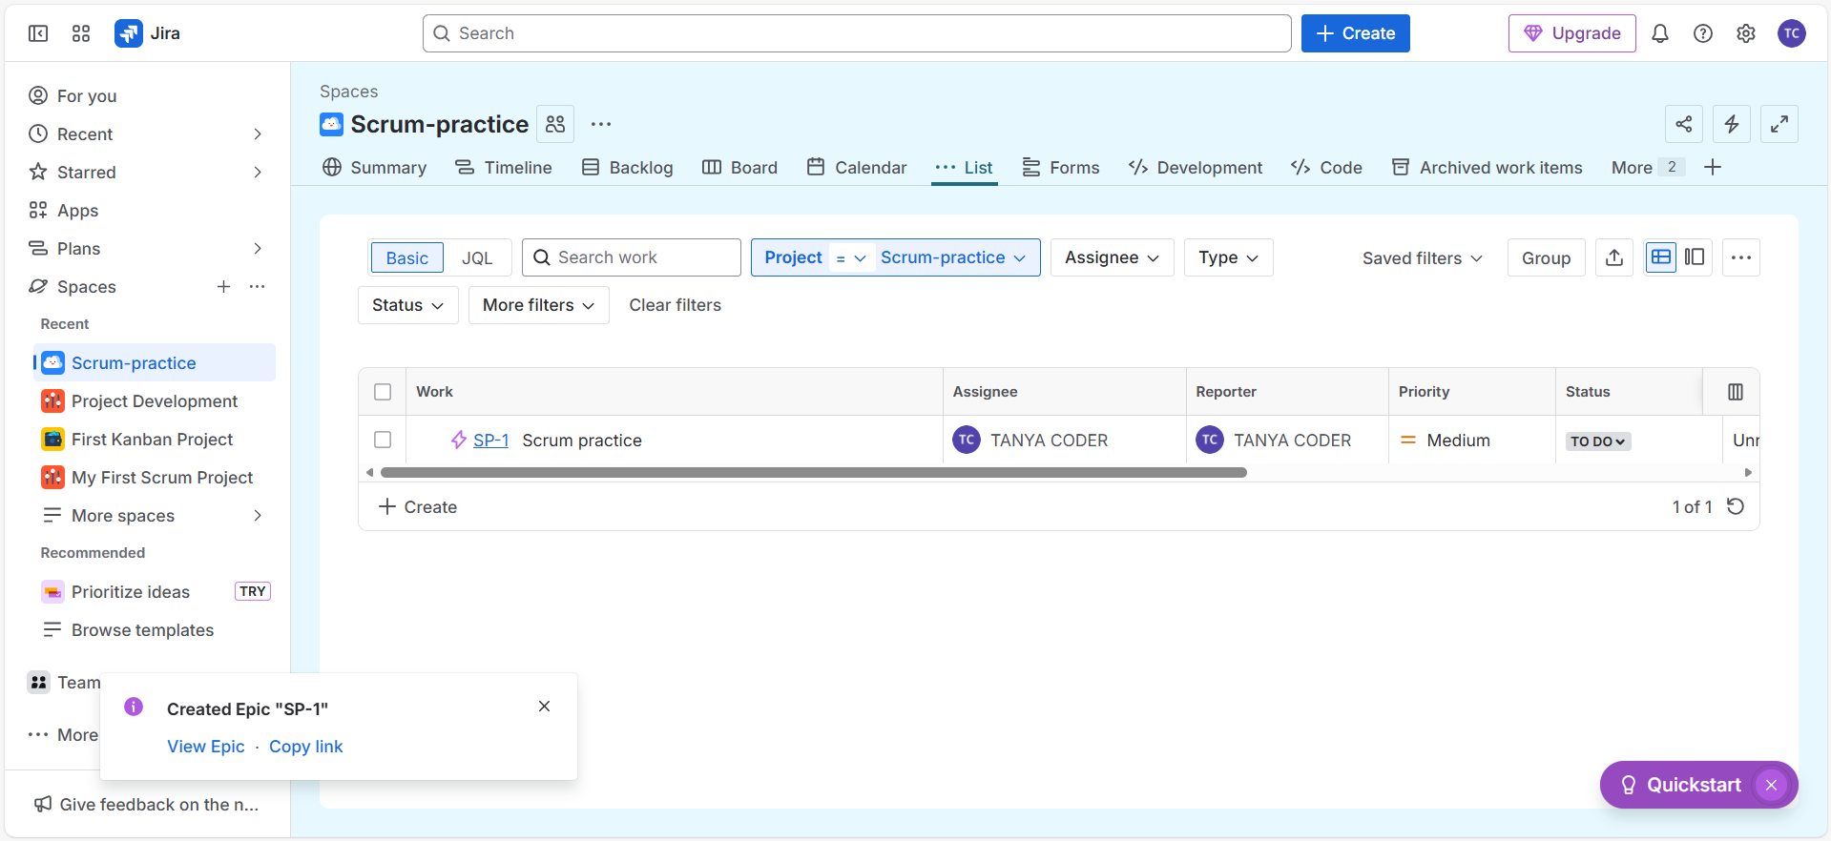

Create Story via the + Create button at the top :

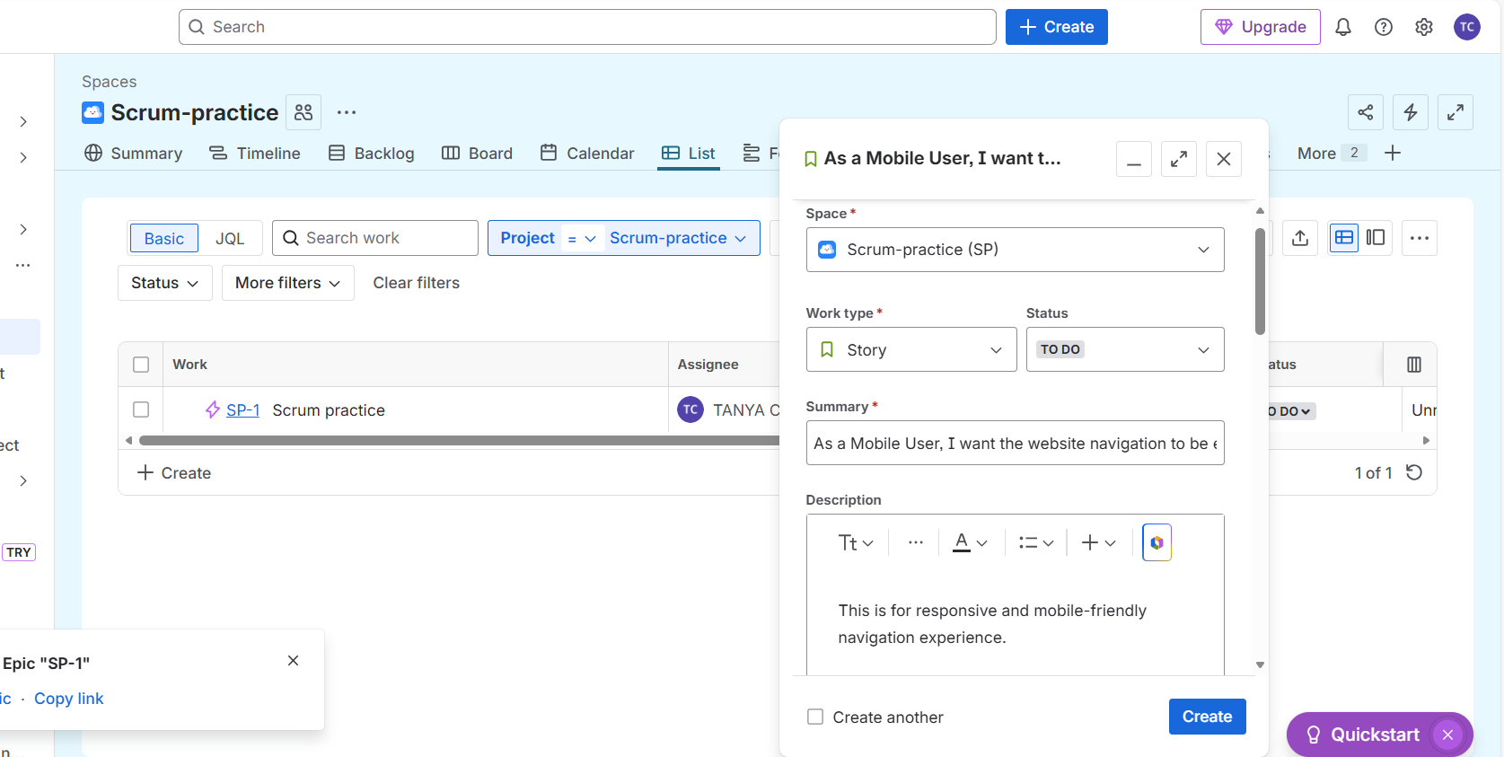

Make sure to add parent for this story, i.e, the corresponding name of the epic 😊

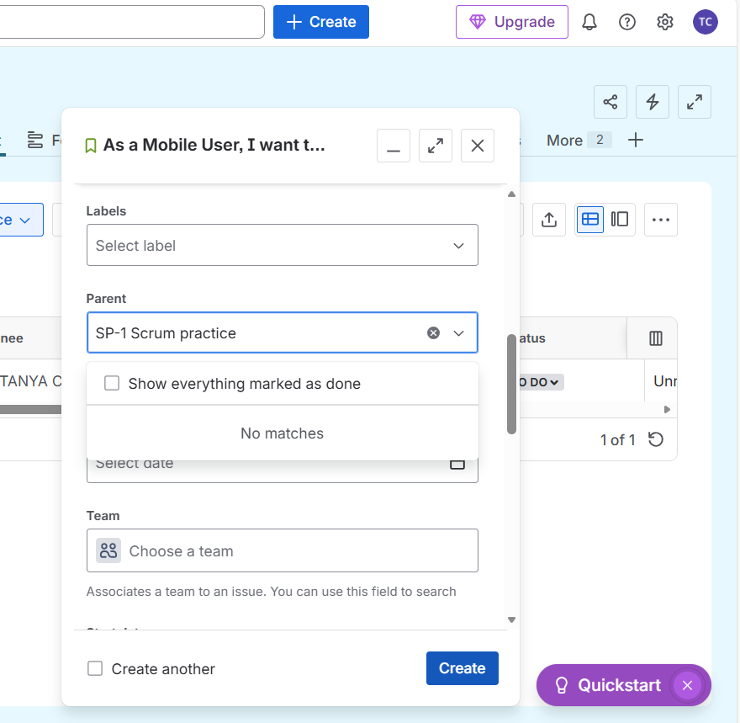

Created other story for the same epic

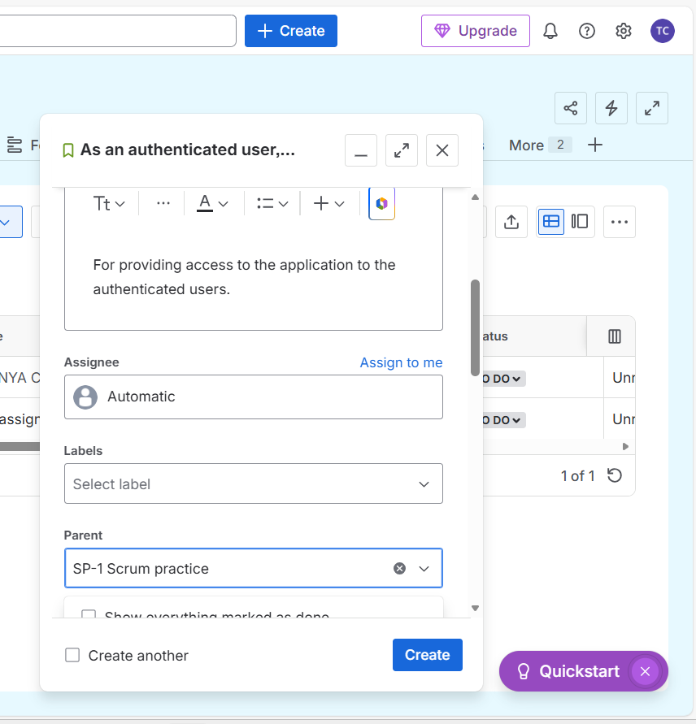

You can view all the stories of the corresponding epic under that epic itself in list

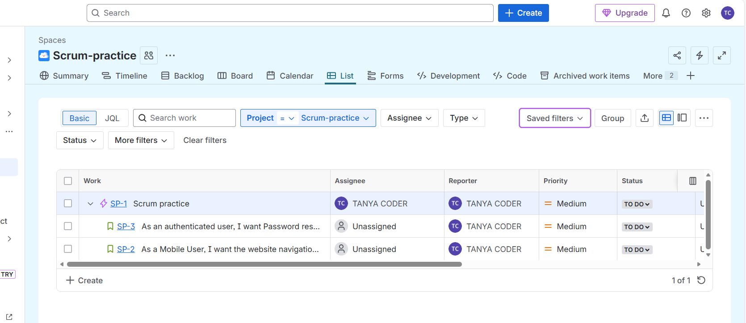

Create tasks for the stories in the same way as clicking on + create button at the top

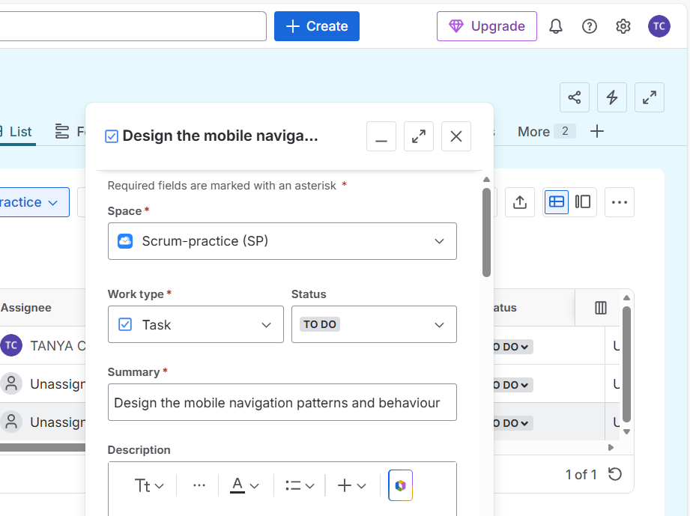

Note:

Story point estimate 🡪 tells how complex is the user story. 100 🡪 complex; 10🡪 easy

Linked work items 🡪 make sure to select ‘relates to’ and then select the corresponding user story the task is related to.

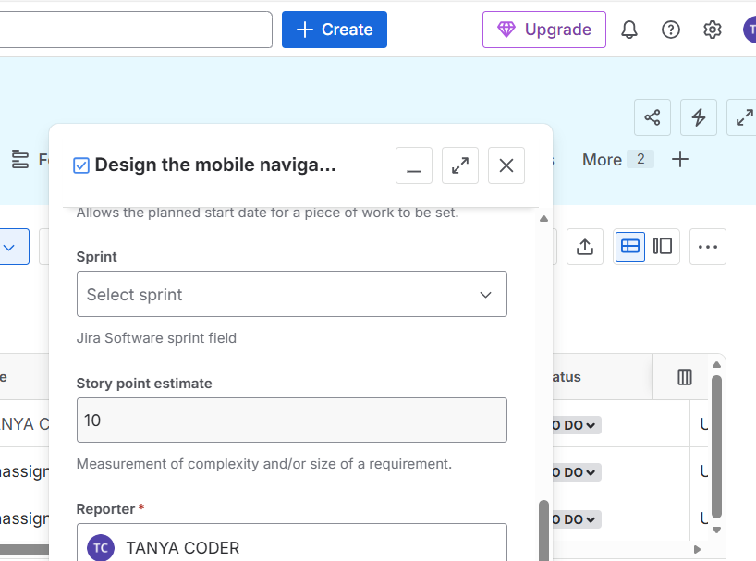

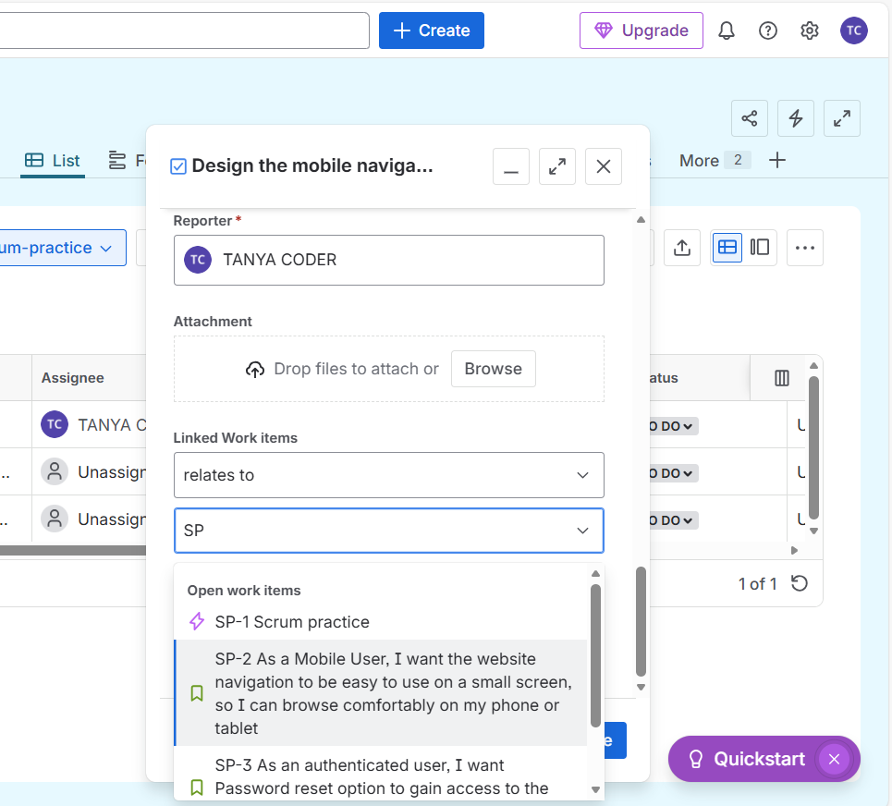

Sprint = a time boxed period during which the team creates a set amount of work (1-4 weeks)

Originally, all the stories will be on the backlog, we can move them to board by selecting the stories and dragging them to top (i.e., Sprint 1)

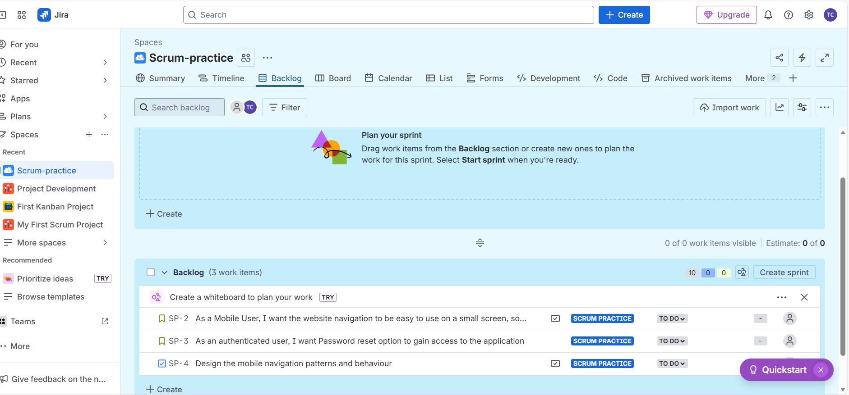

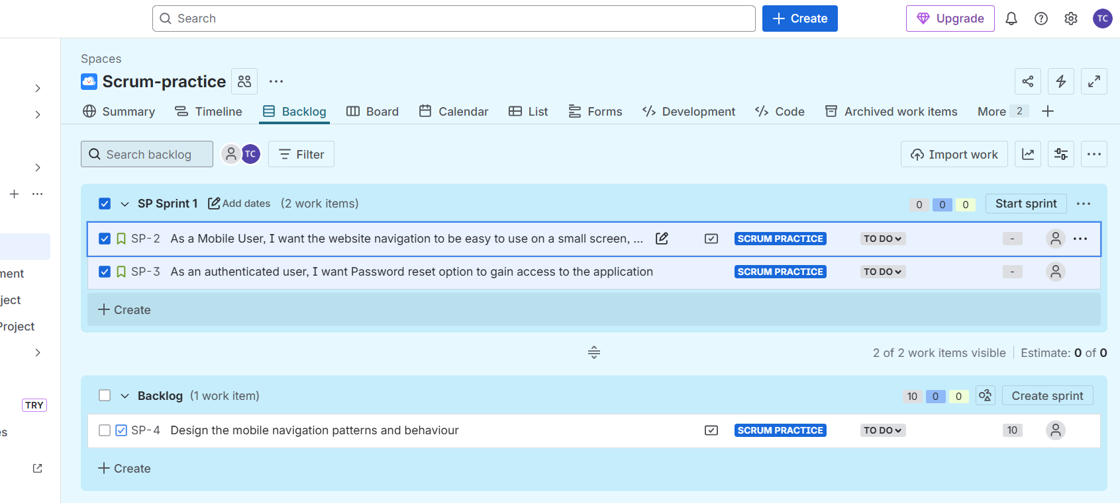

After adding the stories you wanted to Spint, simply click on Start sprint

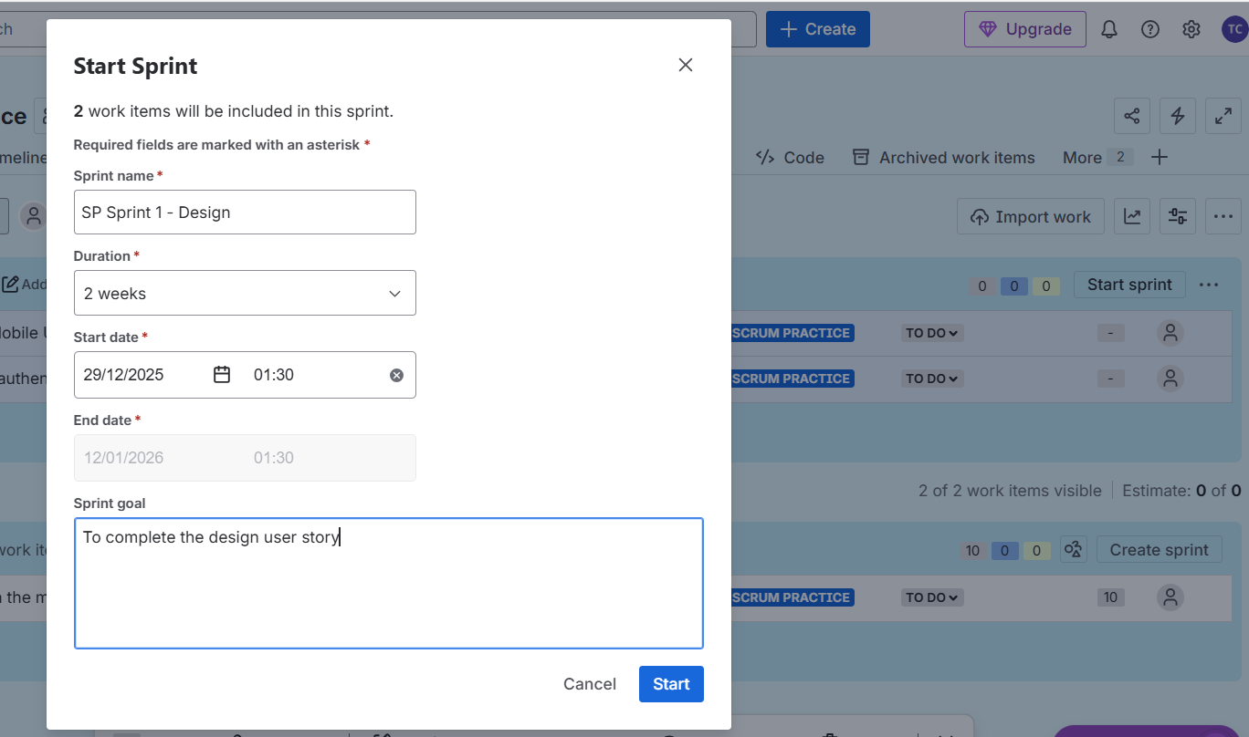

Once you started the Sprint, you can see the selected user stories on board 😊 (also in calendar, timeline etc.,)

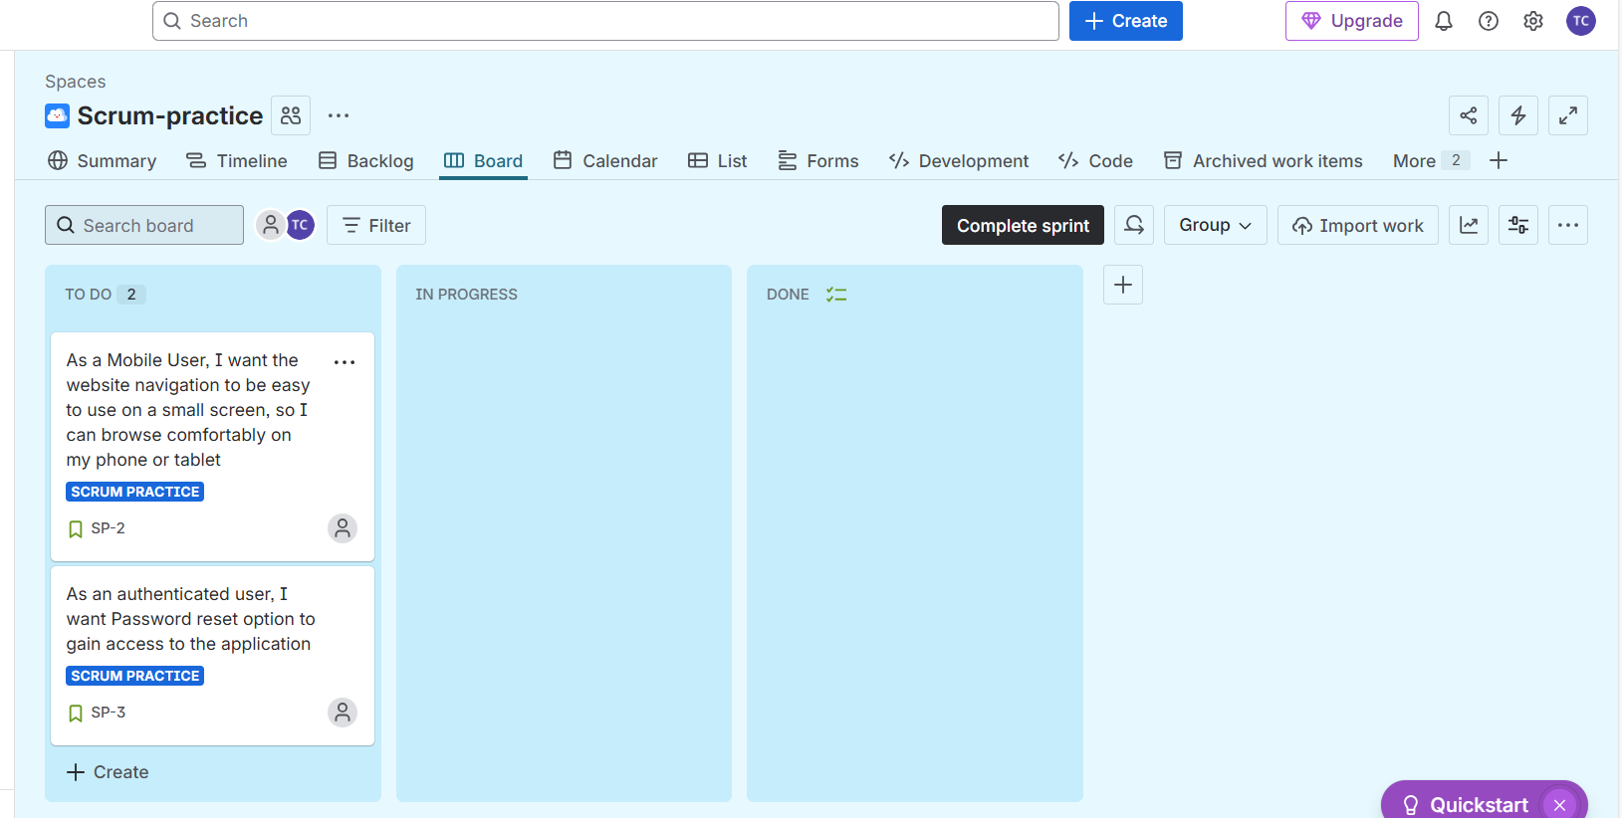

**Creating Team and adding members to it**

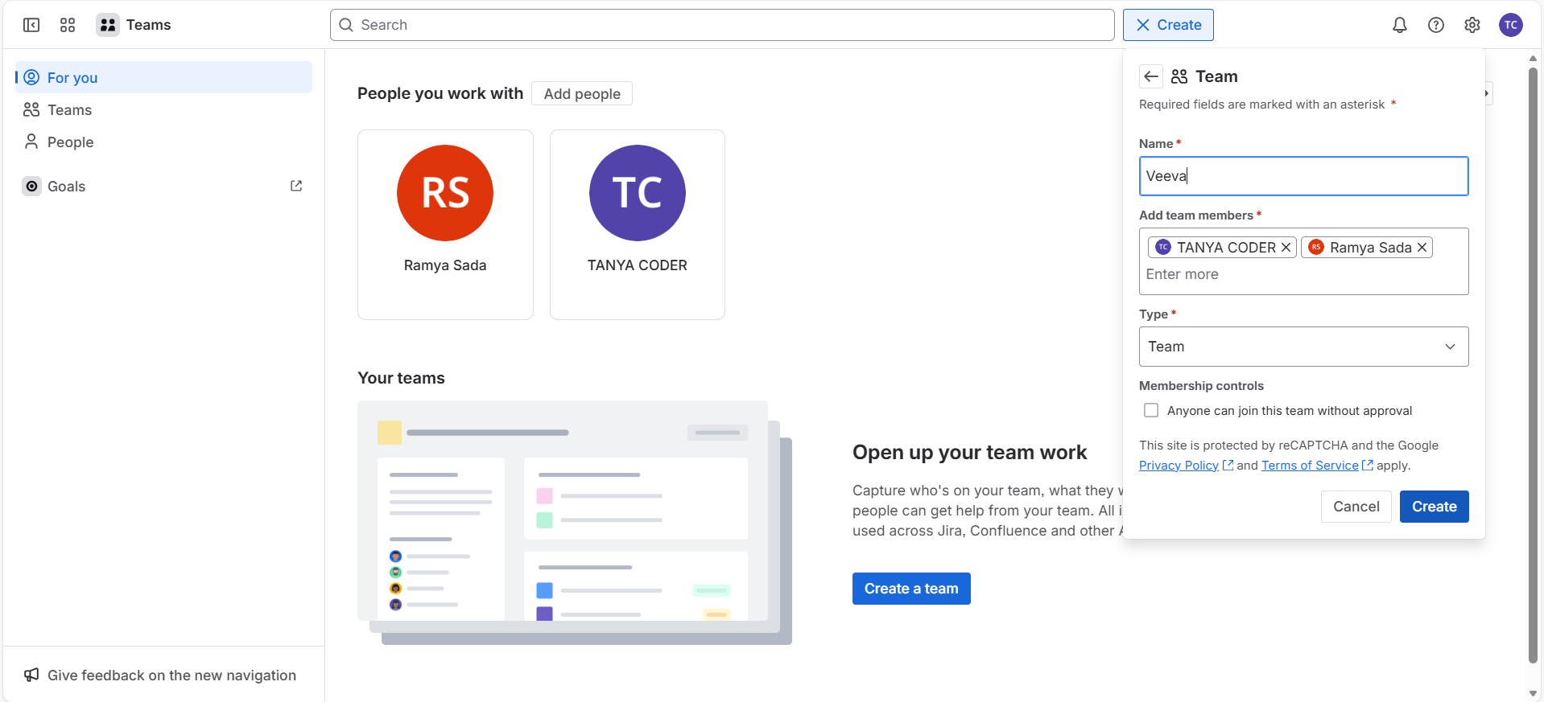

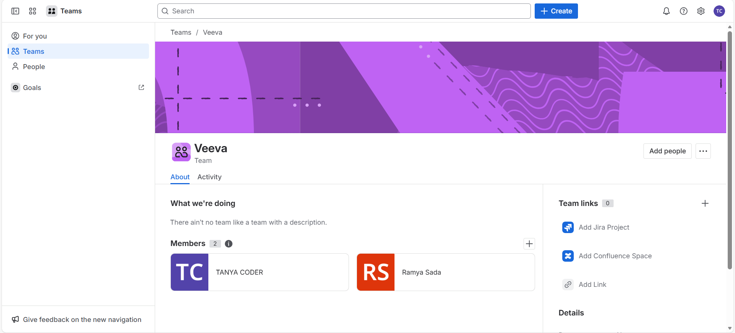

**Creating Epic, Story, Task, Sub task under a new project and their progress movement across the board:**

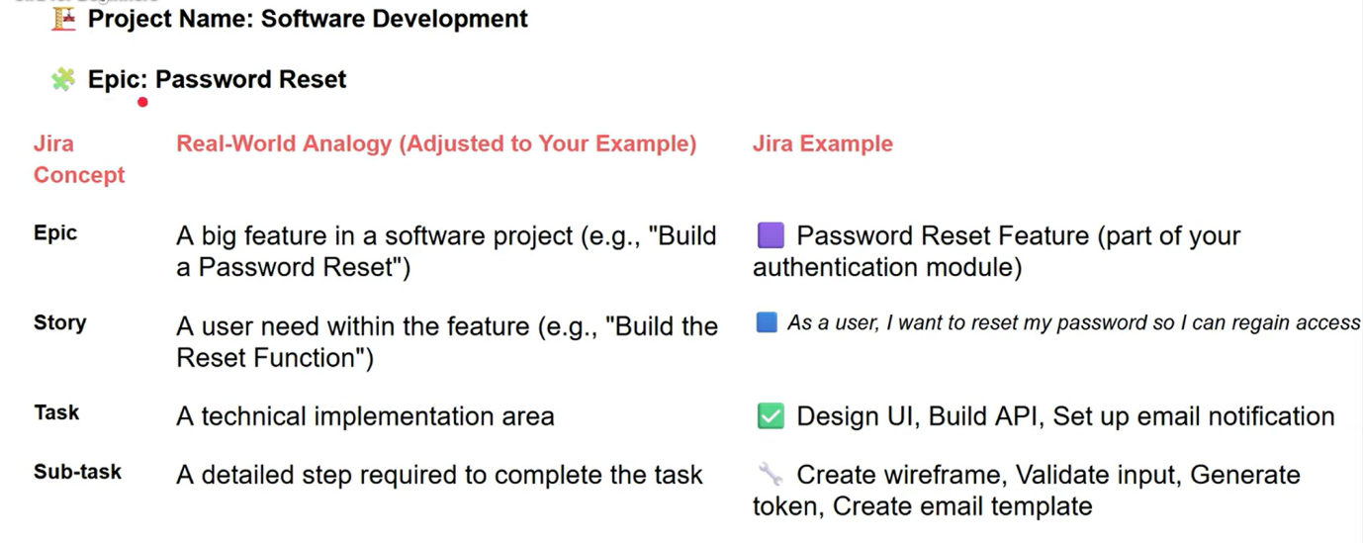

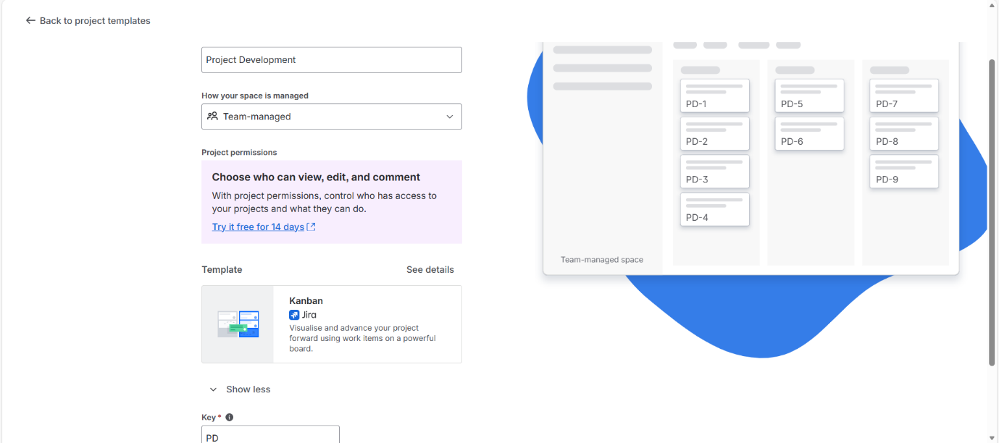

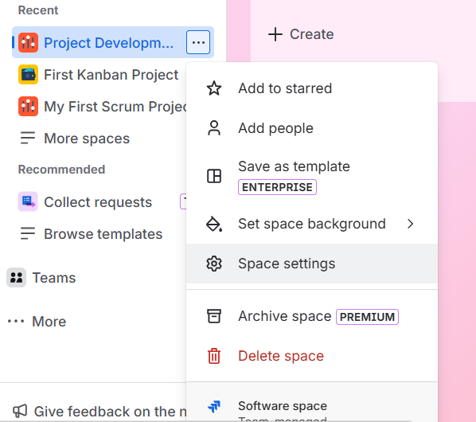

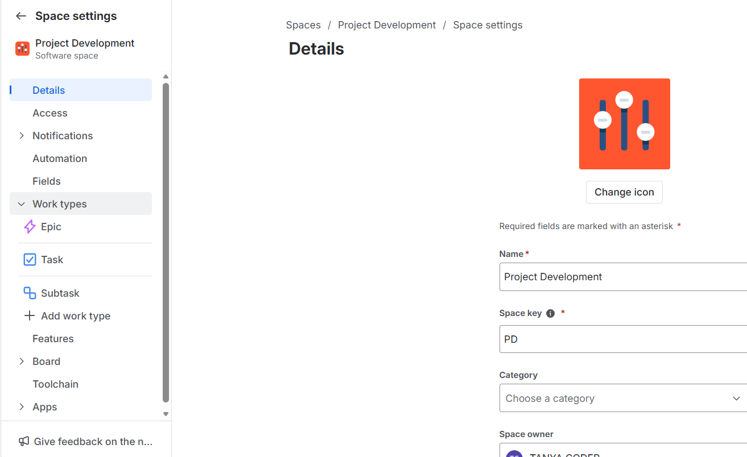

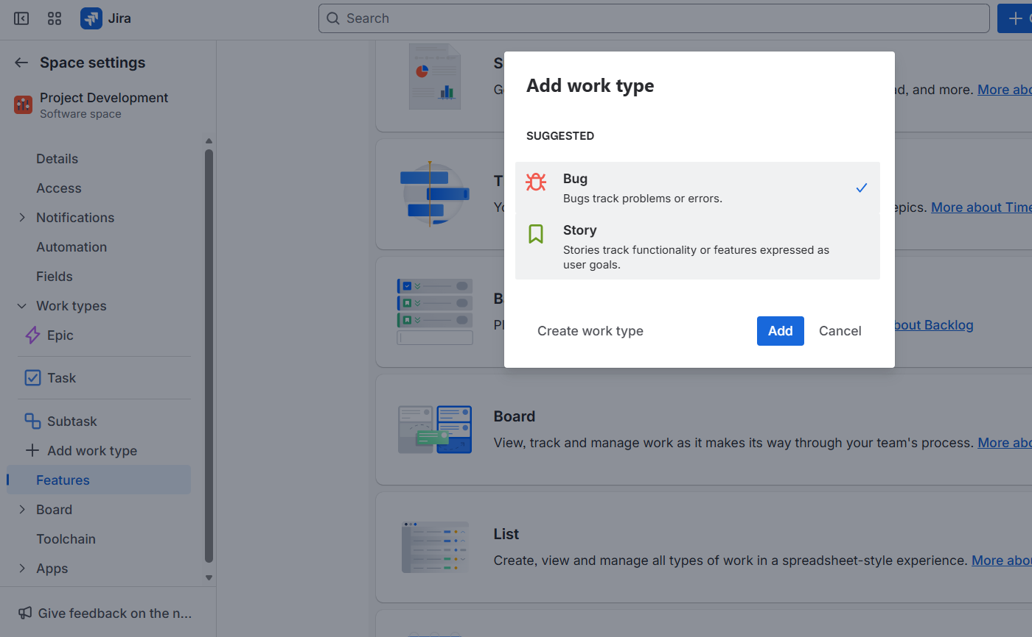

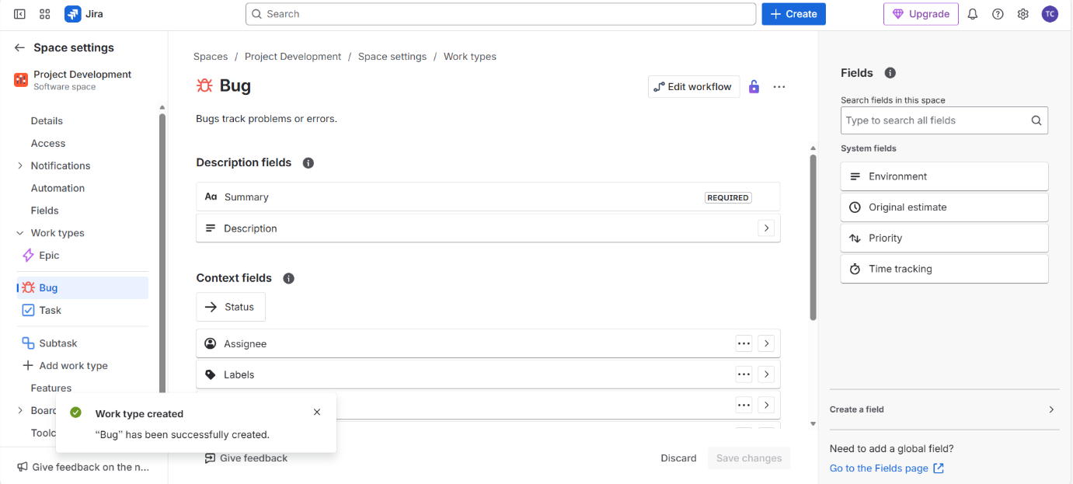

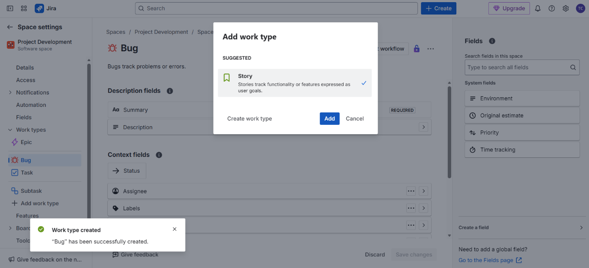

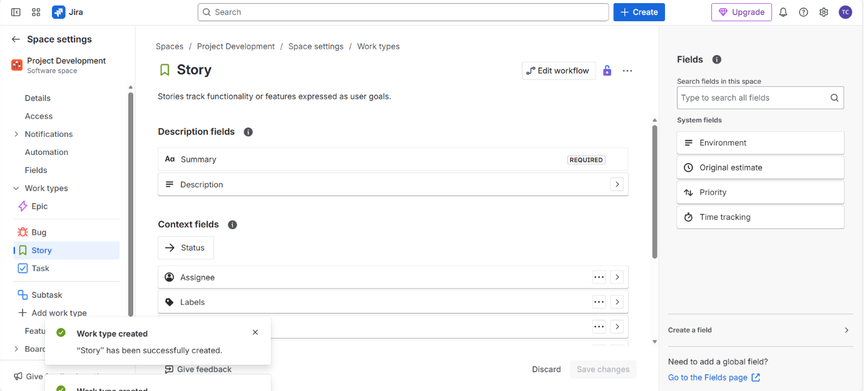

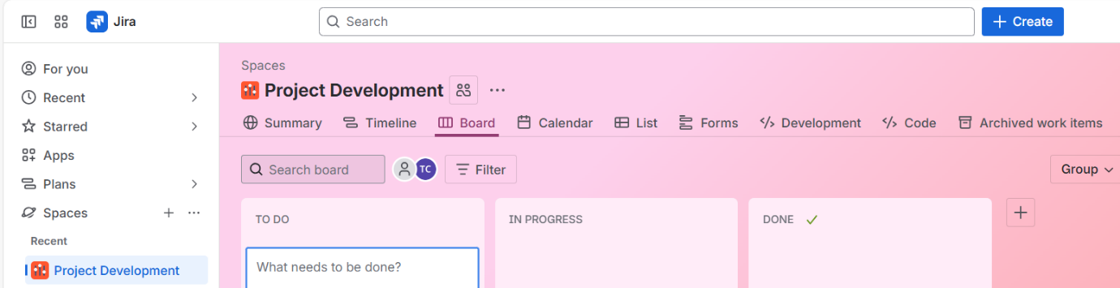

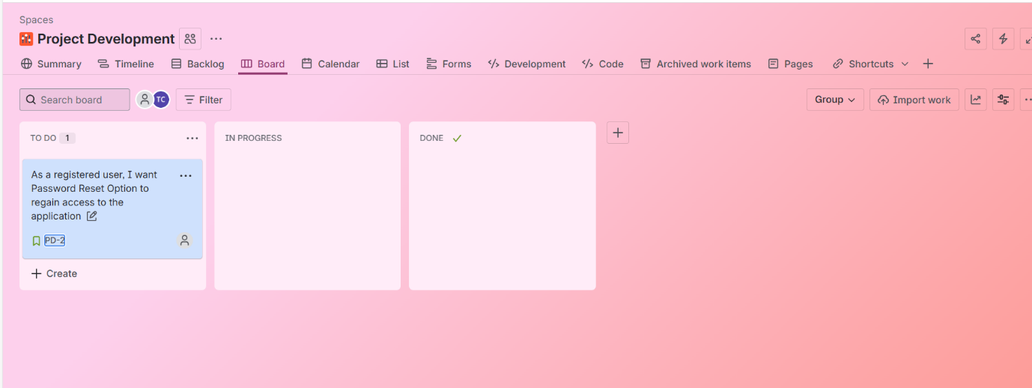

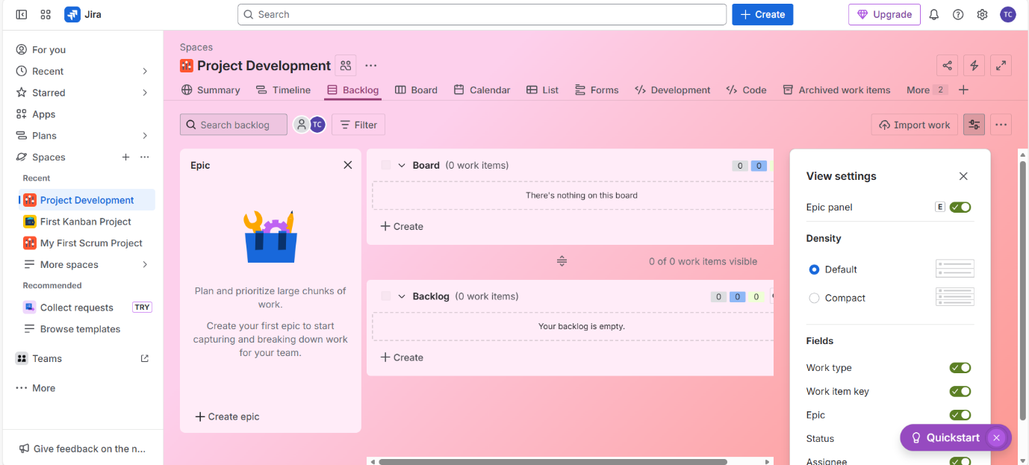

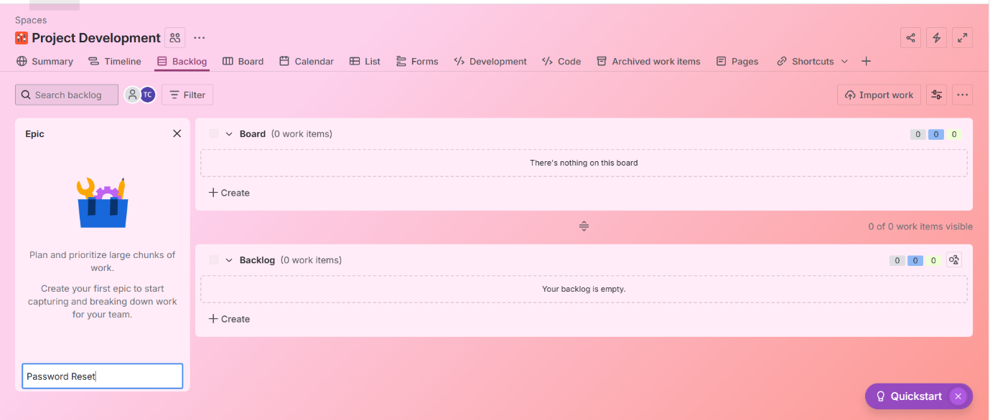

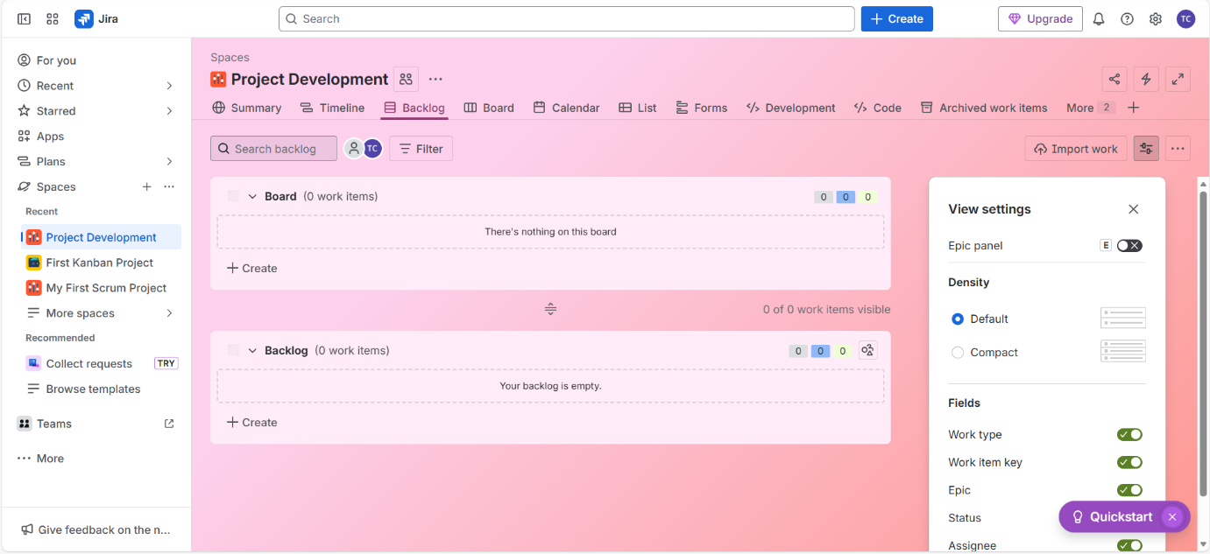

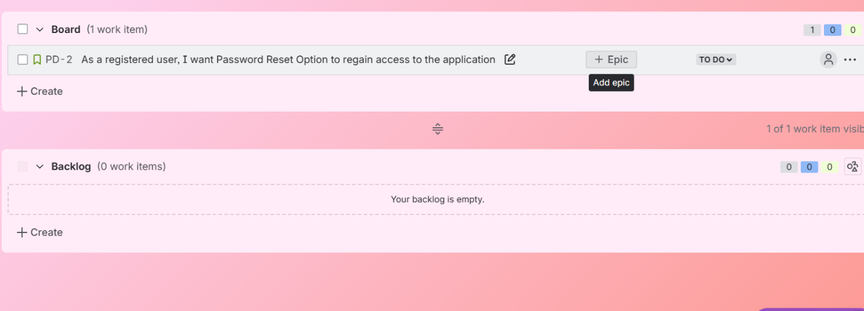

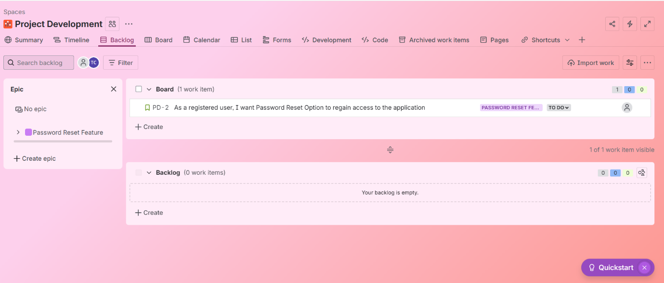

**Creating Sub tasks:**

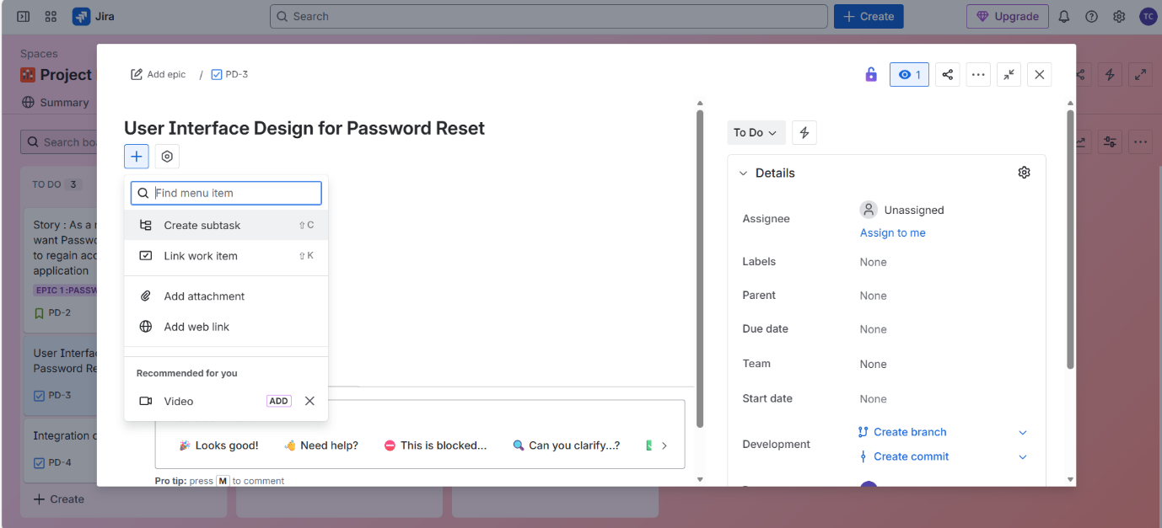

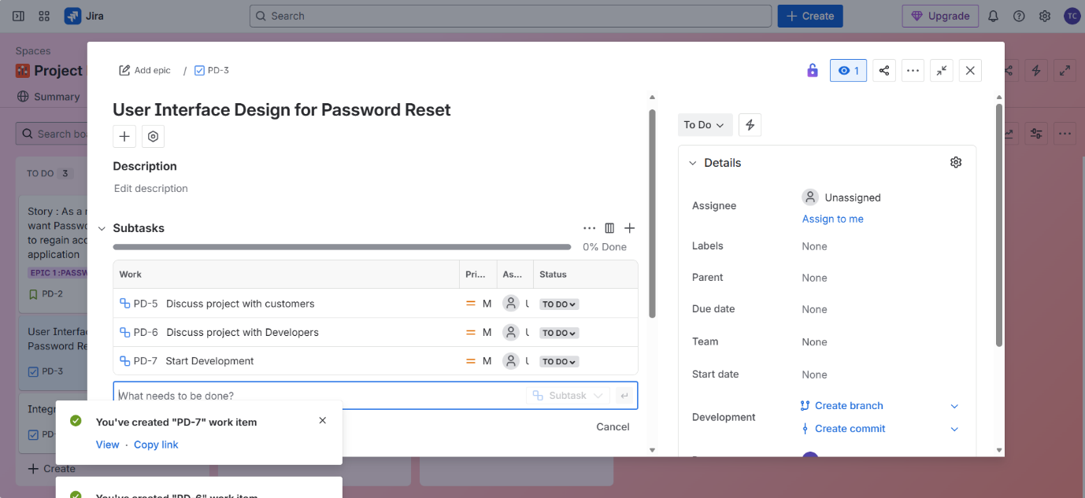

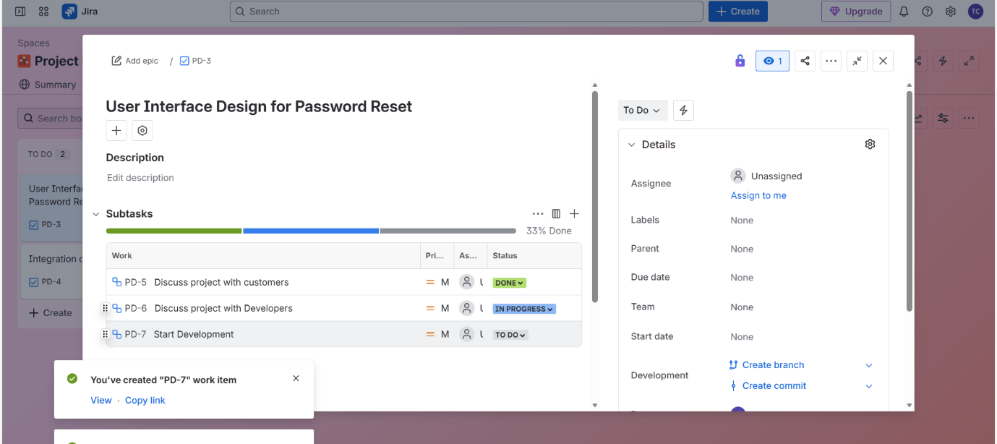

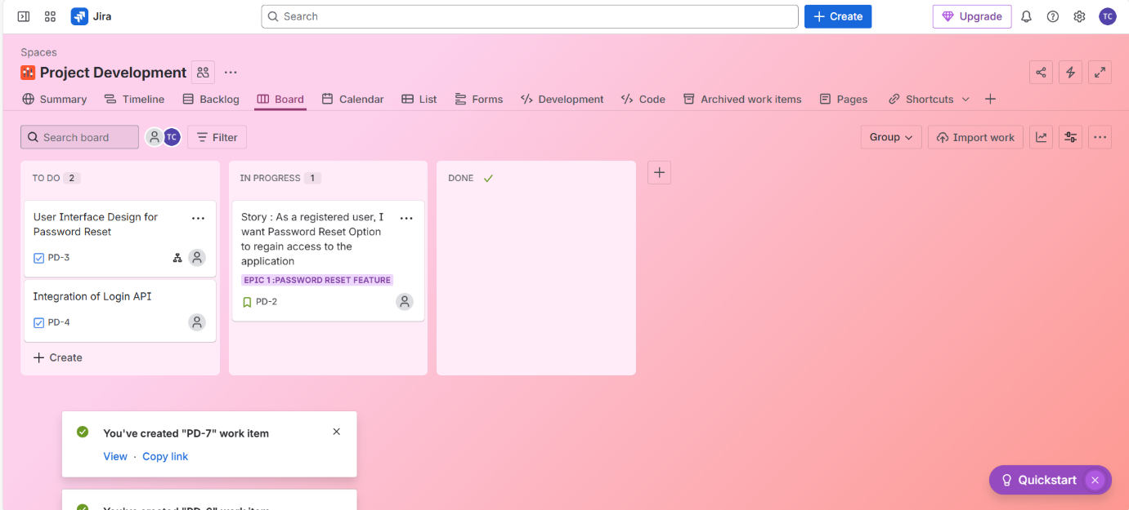

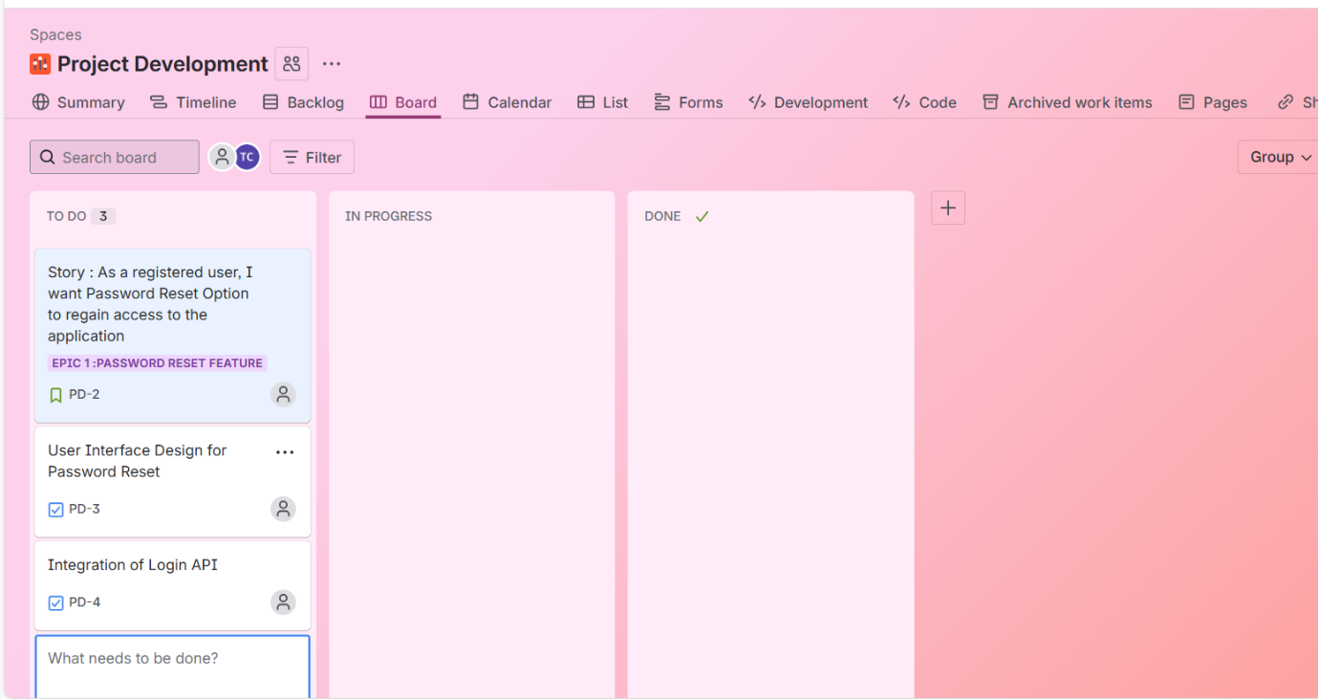

**Creating Bugs**

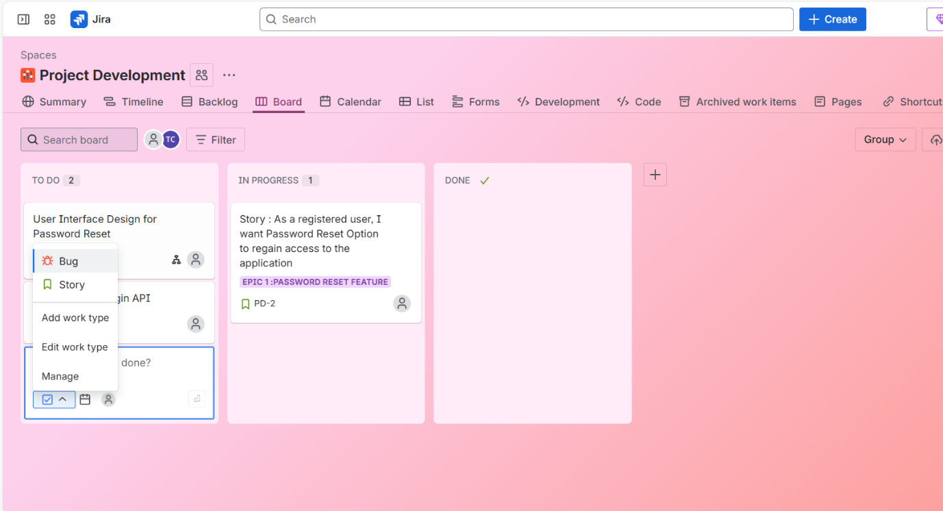

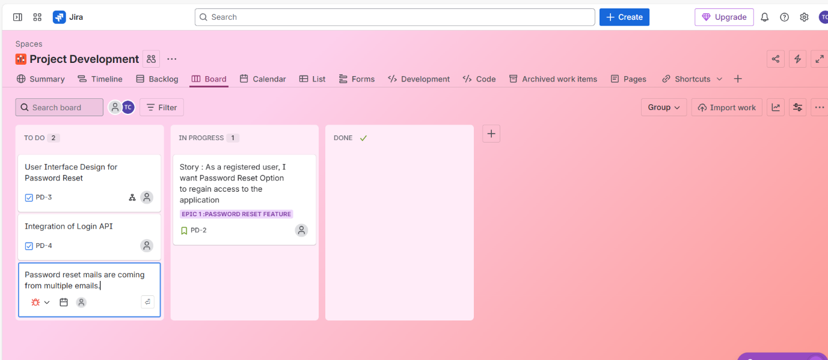

Summary tab, Timeline tab, Calendar tab, List tab can be seen.

Different Templates through new space/new project

**Create Workflow (from more actions):**

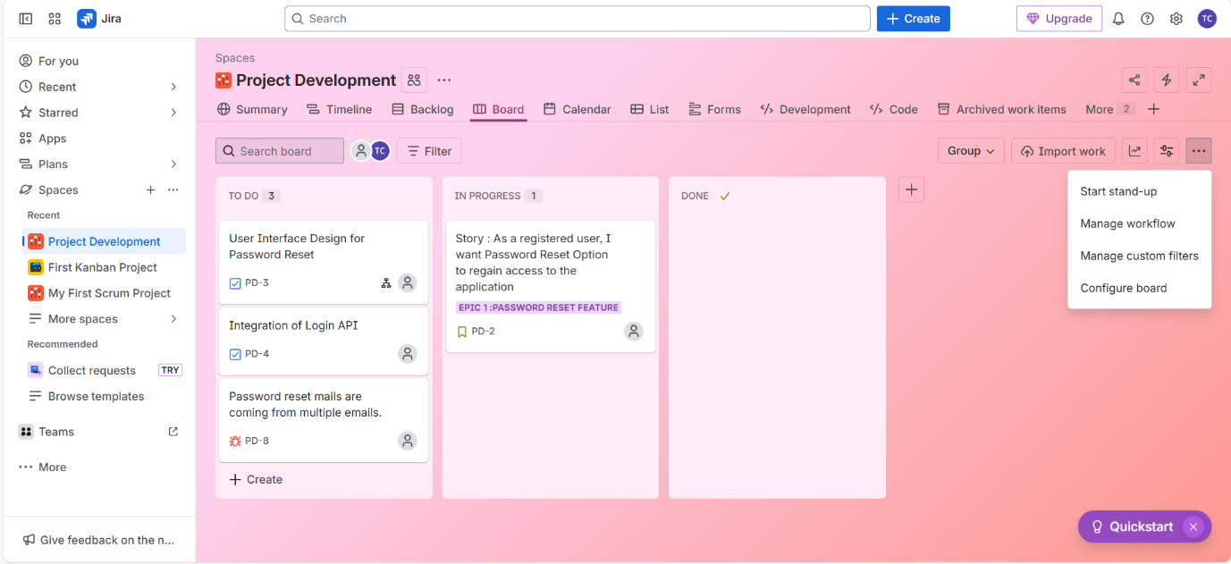

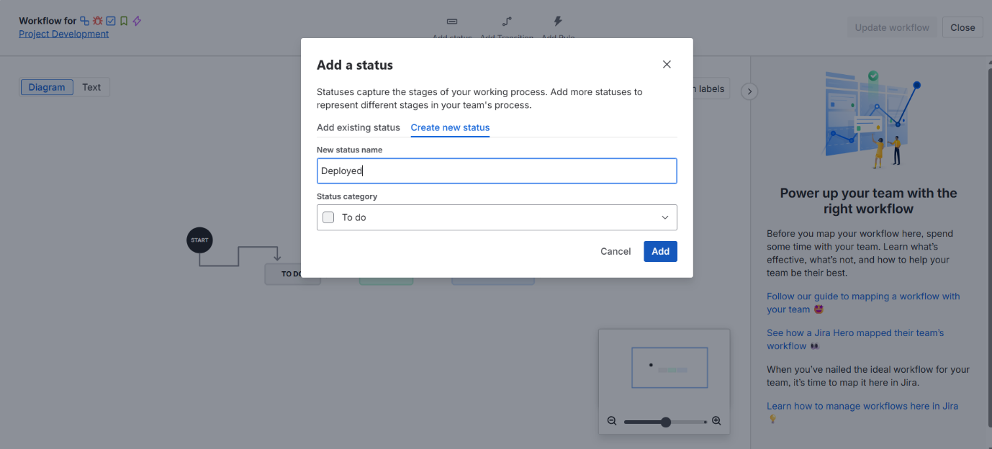

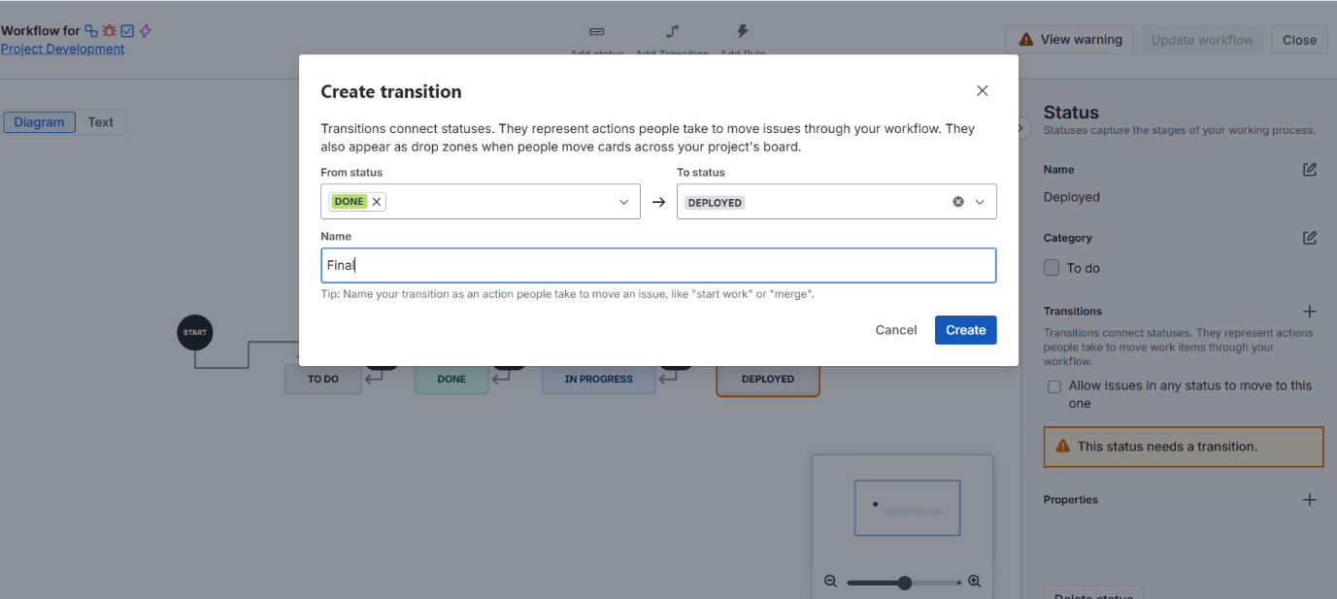

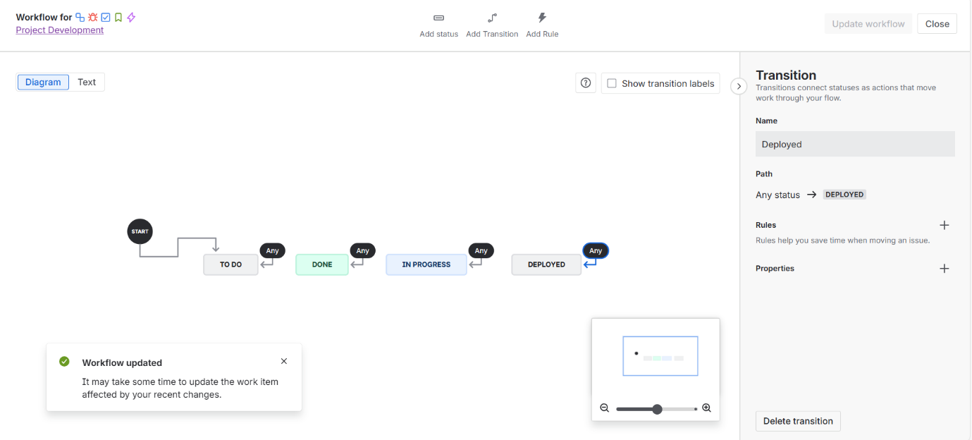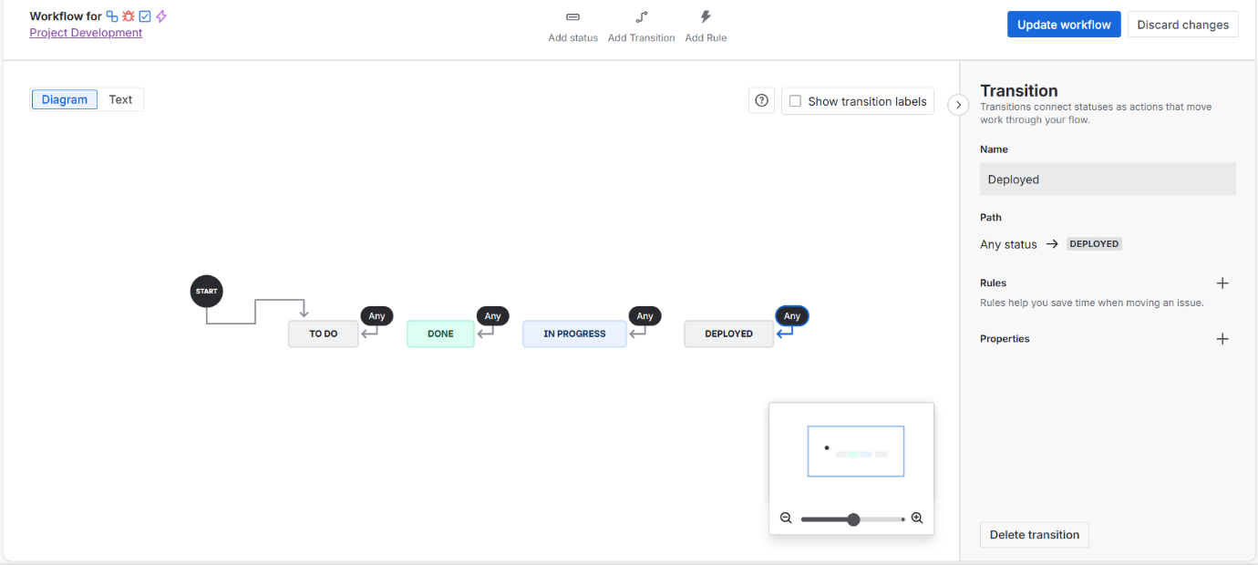

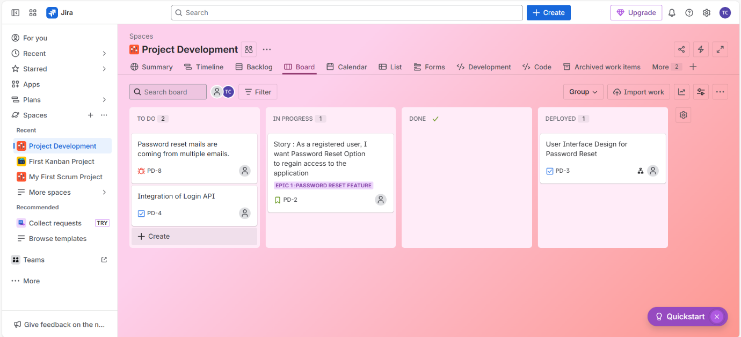

**Code section (for collaboration with tools like BitBucket, Github, Gitlab):**

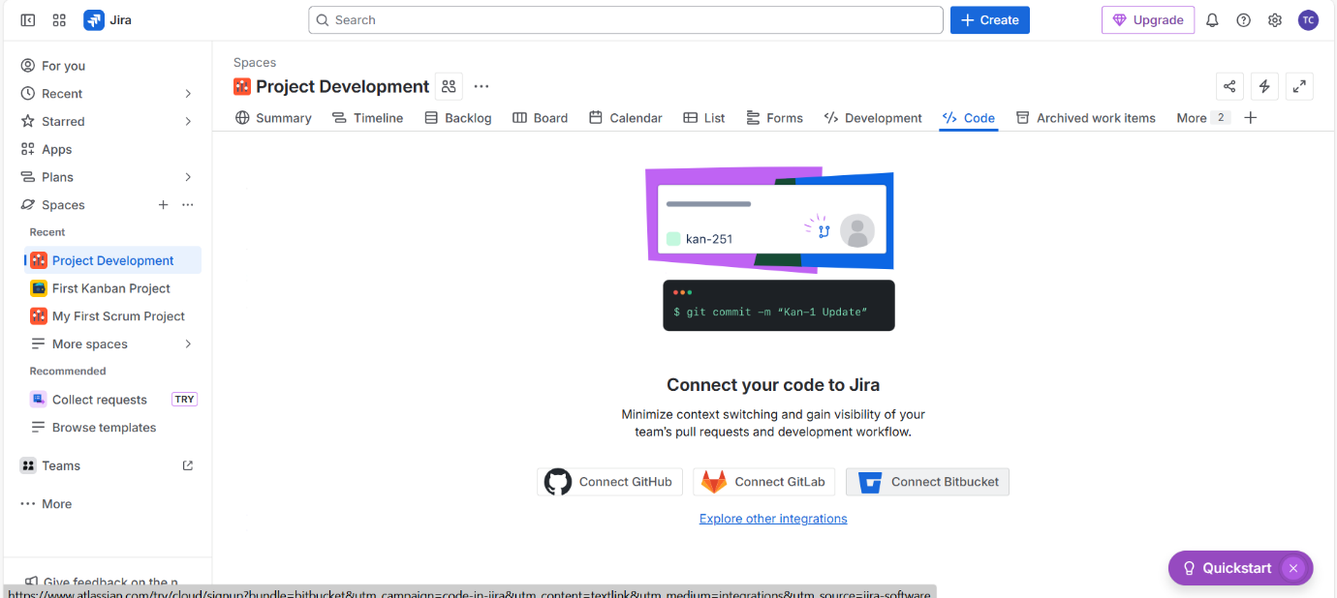

**Releases (from + icon) 🡪 different versions we create**

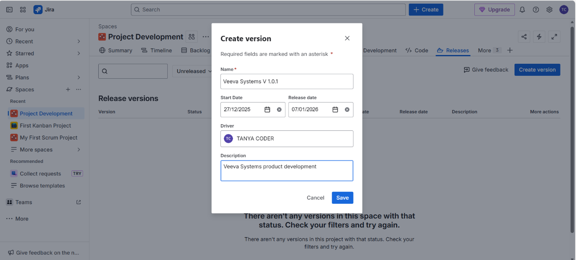

Remove Unused (remove by 3 dots click and click on remove simply, later again you can add to navigation bar 😊)

